Items from Last Report:
1. PCB Debugging: Previous PCBs from the lab have been tested and do not give us accurate results. Testing with a small Raspberry Pico with an ADC was performed for a fundamental review of the sensor. Digital output was able to be read from the sensor.
Current Issues:
1. There are no issues.
Goals for Current Week:
1. PCB Debugging: New PCBs should be ordered and shipped so that we can scale up the design. Further testing of the very basic sensor setup can be done to investigate the effectiveness of the sensor.
2. Microcontroller Investigation: As it takes time for new parts to come in. I will investigate microcontrollers that the lab has or microcontrollers to possibly buy to fit the criteria necessary for this project.
Short Term Goal:
1. Hardware MVP: The hardware will be able to read a signal from the pressure
sensors as a minimum viable product.
Long Term Goal:
- Sensor Signal System: The entire system will deliver a functional sensor and
decoder setup capable of outputting the clean signal required for fish wake data
analysis. July 30, 2026

Appendix
- Raspberry Pi Pico setup with differential sensor
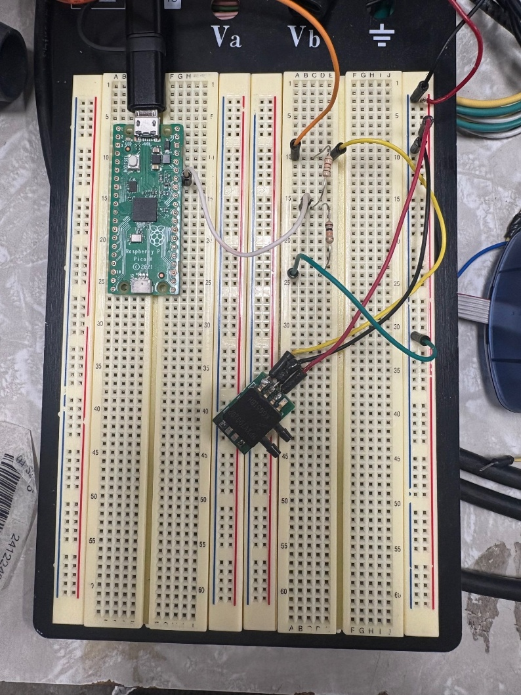
- Digital output and corresponding pressure from value
